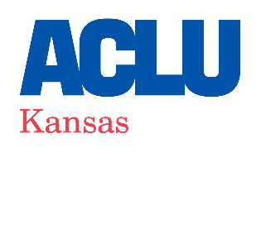
2022 ZANIAL SUMMER LEGAL FELLOWSHIP
(June 1 – August 6, 2022)

POSITION OVERVIEW
The Zanial Legal Fellowship is a paid summer internship in the Legal Department of the ACLU of Kansas—the civil rights litigation arm of this integrated advocacy organization. Our department uses litigation as a tool to vindicate constitutional rights, critique unacceptable government practices, and support the policy and advocacy efforts of grassroots organizers. The Zanial Fellow will be a critical part of our team, assisting our attorneys with every aspect of their work including investigating potential cases, preparing pleadings and motions, drafting research memoranda, assisting with discovery, and participating in court proceedings and client consultations. This position will focus on issues of racial justice and religious freedom. The Zanial Fellow will likely work remotely.

QUALIFICATIONS/APPLICATION PROCEDURE
The Zanial Legal Fellowship is open to 1L students committed to pursuing a career in public interest litigation and enthusiastic about working with a small, dynamic team of attorneys passionate about their work. Please submit a detailed letter of interest, a current resume, and a legal writing sample of no longer than 10 pages. Email your application to:
Sharon Brett
Legal Director, ACLU of Kansas sbrett@aclukansas.org

Please include “Zanial Summer Fellow” in the subject line. Applications will be reviewed beginning the week of January 18, 2022 and will be accepted until the position is filled. No calls or in-person applications, please.

COMPENSATION
Fellows are paid a $3,000 stipend in two installments. The first installment is paid during the first week of the fellowship and the second installment is paid during the fourth week of the fellowship.

ABOUT THE ACLU OF KANSAS
The American Civil Liberties Union (ACLU) of Kansas is a non-profit and non-partisan organization dedicated to preserving and advancing the civil rights and legal freedoms guaranteed by the United States Constitution and the Bill of Rights. The ACLU of Kansas works in the state legislature, the courts, and local communities to protect the rights of all people living in Kansas. The organization’s work includes efforts to strengthen and defend First Amendment rights, voting rights, reproductive rights, racial justice, LGBT rights, immigrants’ rights, stopping government surveillance, and reforming the criminal justice system. The ACLU of Kansas often works in broad-based coalitions made up of individuals and organizations from across the political, partisan, and ideological spectrum.

The ACLU of Kansas is an equal opportunity employer. We value a diverse workforce and an inclusive culture. The ACLU of Kansas encourages applications from all qualified individuals without regard to race, color, religion, gender, gender identity or expression, sexual orientation, age, national origin, marital status, citizenship, disability, and veteran status.

